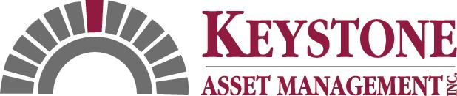

KEYSTONE ASSET MANAGEMENT INC.
KICKS OFF NATIONAL TRAINING PROGRAM

FOR IMMEDIATE RELEASE CONTACT: Wendy Madonna
215-855-3350 ext. 142

LANSDALE, PA (May 6, 2008) – Keystone Asset Management Inc., a national provider of comprehensive REO, Default Management and Property Valuation Services recently conducted a national training program for its existing brokers and agents. The training program took place at the Buena Vista Palace Hotel & Spa in Orlando, FL and included brokers and agents working with Keystone REO properties across the country.

This was the first national training program designed by Keystone for the purpose of educating its brokers and agents on business process efficiencies, website technology, multi-client requirements and staff operations. Over 160 brokers and agents gathered at the event, boasting rave reviews for the Keystone team. A number of organizations joined in to sponsor the program. Special recognition was given to Cheryl Lang of IMS for initiating No Paws Left Behind, a new not for profit organization created to protect the rapidly increasing number of innocent pets who are victims of the foreclosure crisis.

The training event was intended to assist brokers and agents in streamlining their business and increasing proficiencies that can help them to sell more properties in a shorter time frame. “With all the increased pressure of the industry, proper training becomes a main priority. We wanted to reach out to our brokers and agents to make sure they fully understand how to process the listings they receive from Keystone,” said Nick Salamone, President of Keystone Asset Management. “We know their time is very valuable, so it was important to hold an event that would be short but very effective.”

Due to an overwhelming response to this initial program, Keystone will host its second event toward the end of 2008. “I really enjoyed the training program,” said Herlinda Sandoval-Ryan of Keller Williams Realty. “We received a number of great tips and information to help us in our operations and we were glad we attended.”

Keystone Asset Management is nationally recognized for providing superior client-driven services for the default industry. Its success stems from continued investment in professional staff, advanced technology and strategic alliances.

For more information visit the Keystone Asset Management website at www.keystonebest.com or call (215) 855-3350 ext. 114.

###

